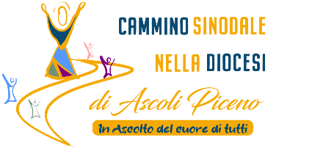
Il cantiere dei villaggi e delle strade

L’ascolto nei Consigli Comunali
Breve letture tratte dal cap. 5 Enciclica Fratelli tutti – La migliore politica
Divisione in gruppi per l’ascolto con le seguenti domande utili all’ascolto
- Con lo sguardo rivolto al tuo percorso politico, come stai?
____________________________________________________________________________________________________________________________________________________________________________________________________________________________________________________________________________________________________________________________________________________________________________________________________________________________________________________________

b) Come sta la città?
____________________________________________________________________________________________________________________________________________________________________________________________________________________________________________________________________________________________________________________________________________________________________________________________________________________________________________________________

c) Cosa pensi la Chiesa possa fare per la città?
________________________________________________________________________________________________________________________________________________________________________________________________________________________________________________________________________________________________________________________________________________________________________________________________________________________________________________________________________________________________________________________________________________________________________________________________________________

